# Puzzle Walker

Android game where you move by dragging a character through a 2D puzzle map filled with traps, tricks and snares.

# People

Audio: Freeman, Dan

Artist: beg Kyle?

Programers: AndrewB, Sheeps, me, LarryK

Game Design: AndrewB, Sheeps, me, LarryK

Storyboard: Me

# Levels overview:

Splash

Pause

_Level 03

End Screen

_Level 02

_Level 01

Options

Start Menu

# TO DO LIST

Splash screen:

* Music Player
* Level Loader

Start Menu:

* Start button
* Option button
* Quit button
* Background artwork

Options menu:

* Music volume
* Sound volume
* Back button
* Background artwork

Pause menu

* Music sound level
* Sound volume
* Resume button - DONE
* Pause artwork
* Needs to be able to resume wherever player left off. - DONE
* Need to have quit button to save and quit

# Cutscenes

Requirements:

* Script (Separate document)
* Text button on the bottom left – Click to hop to the next text box.
* Need skip button on the right. – Hold for 2 seconds to skip the Cutscene > screen grays and pie graph fills
* Music
* Campfire ambiance
* Bird and owl sounds
* Pulsing light fixture of the camp
* Green color asset for the floor
* Entrance to cave on the right

# Controls

Set thumb on the main character and drag him to move. – implication is that the puzzles might have to be larger so the finger doesn’t block view

Other alternative – trace with finger left right up down, then can remove and have the line saved until you resume moving it – Implication is that you can look at screen without having to have your fingers in the way, but the removes the death animation from the game and potentionally a significant chunk of the story.

# Camera setup

World units = 10 x axis so pixel per world unity = 192

**Background MUST BE 1920x1080**

Aspect ratio = 1.7 roughly

# Modelling puzzles after the following image:

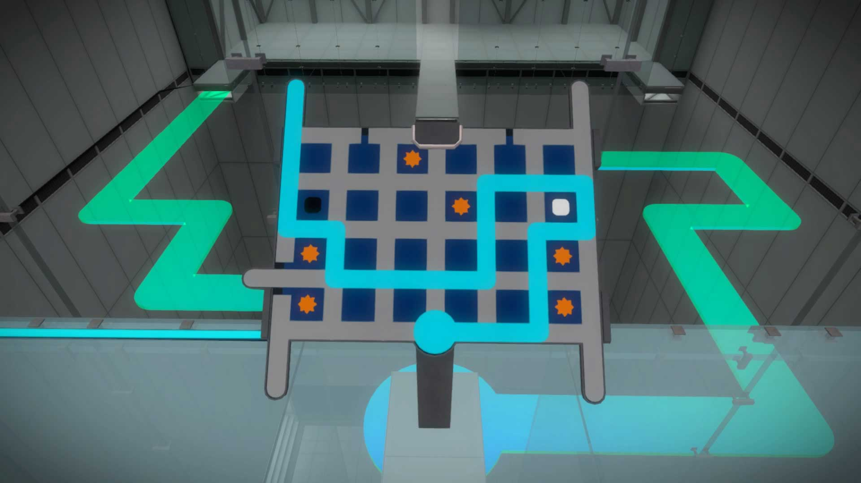

# Level 1:

## Notes:

Most basic puzzle in the game

Goal is to show how the puzzle mechanic works

Needs to be obvious to player that holding down the player character and dragging will move him forward

Make the player character on the starting circle

Others light up as you trace along them

When you trace to the end point, the next level loads

## To Do

Need to set up a grid system created with game objects

Need to set up camera - **done**

Need to animate character entering the level through the door and having the specter wife stand beside him

Need to animate the main character standing with ghost (Blinking eyes and awaiting input)

When you press your thumb on the characters, they separate and the ghost wife becomes drag-able across the grid. > Light blue trace color shows the path that she hovers.

Need to animate the ghost of his wife hovering when thumb is on her

Need to animate the husband waiting for her alone.

Need to give walking animation of the husband walking the puzzle and making it to the other side.

When you reach release the wife, the path does one of two things:

* Either it fails: Turns red, and there is a death animation for the man at the start. Then a flash of light and he is resurrected hand in hand with his wife.
* It succeeds and the husband walks the path to the opposing door and gets out

**When walk succeeds:**

Camera swipes right to next level in the dungeon where the husband and wife appear on the left again.

**UI Goals:**

Need to suggest that player should press thumb on characters and drag *without* drawing arrows or explaining the mechanic

Need to make a straight line to exit so player gets what he’s doing.

Need to have death animation in case player releases wife figure before hitting the exit.

# Level 2

Need to show what happens if the wife’s ghost coils on its own tracer, which is that it gets blocked and can’t go further.

Need to show what happens when you take the incorrect path to the end goal